🌾 OptiCrop: Smart Agricultural Production Optimization Engine

Project Description
OptiCrop is a Machine Learning-powered web application that helps farmers decide which crop is best suited to their land, replacing guesswork and informal advice with a data-driven recommendation. The user enters seven soil and climate parameters — Nitrogen (N), Phosphorus (P), Potassium (K), temperature, humidity, soil pH, and rainfall — and the app instantly returns the most suitable crop, a confidence score for that prediction, and two backup crop suggestions.
The recommendation engine is powered by a Random Forest Classifier trained on the Kaggle Crop Recommendation dataset (2,200 records across 22 crop classes). The trained model is serialized with pickle and loaded once at runtime, so predictions are returned instantly without any retraining. The entire experience — input form and results — is delivered through a single-page Streamlit interface, making the tool simple, lightweight, and free for end users to access with no installation required.

Scenarios
Scenario 1: A smallholder farmer in a semi-arid region enters their soil test values (low N, moderate P and K) along with the season's average temperature, humidity, and rainfall. OptiCrop recommends a drought-tolerant crop such as millet or chickpea, along with two backup options, helping the farmer avoid planting a water-intensive crop that would likely fail.
Scenario 2: An agricultural extension officer uses OptiCrop during a village outreach session, entering soil parameters for several farms in sequence. The instant confidence score lets the officer quickly flag borderline cases (e.g., a 54% confidence prediction) for further soil testing, rather than treating every recommendation as absolute.
Scenario 3: A student or hobbyist gardener with no agricultural background enters generic soil-kit readings out of curiosity. OptiCrop returns an easy-to-understand crop name with a percentage confidence and two alternates, making crop science approachable without needing to interpret raw NPK numbers.

Technical Architecture
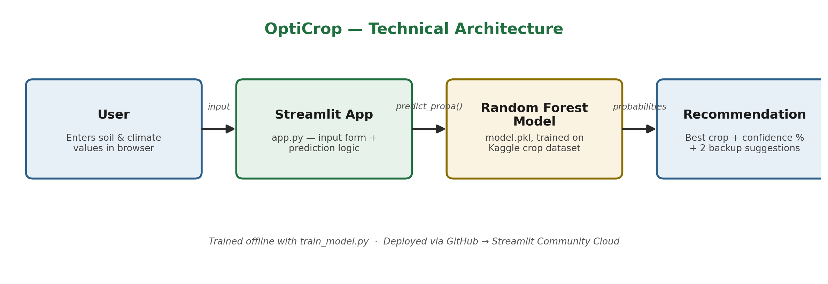

Description: OptiCrop follows a simple three-layer architecture. The Streamlit frontend renders the input form and results directly in the browser. app.py acts as the backend logic layer — it validates user input, loads the pre-trained model, and calls model.predict() / predict_proba() to generate a recommendation. model.pkl, a Random Forest Classifier trained offline in train_model.py, is the persisted ML artifact loaded once at app startup. The whole application is deployed to Streamlit Community Cloud, which connects directly to the project's GitHub repository and automatically redeploys on every push.
Note: This project does not use a database — it is a stateless, single-page tool. No ER diagram is required.

Pre-requisites
- Python Programming Proficiency: core language for data processing and the ML pipeline (Python 3.8+).
- pandas & NumPy Familiarity: for loading, cleaning, and transforming the crop dataset.
- scikit-learn Knowledge: for training and evaluating the Random Forest Classifier.
- Streamlit Framework Knowledge: for building the input form and results UI (docs.streamlit.io).
- Version Control with Git: for pushing code to GitHub ahead of deployment.
- Streamlit Community Cloud Familiarity: for one-click deployment from a public repository.

Project Workflow

Milestone 1: Dataset Selection and Model Architecture
- Activity 1.1: Source and understand the Crop Recommendation dataset.
- Activity 1.2: Research and select the appropriate ML algorithm.
- Activity 1.3: Define the application architecture.
- Activity 1.4: Set up the development environment.

Milestone 2: Model Training and Core Functionality Development
- Activity 2.1: Load, explore, and clean the dataset.
- Activity 2.2: Split features/target and create train-test sets.
- Activity 2.3: Train and evaluate the Random Forest Classifier.
- Activity 2.4: Persist the trained model as model.pkl.

Milestone 3: app.py Development
- Activity 3.1: Load the trained model and configure the Streamlit page.
- Activity 3.2: Build the 7-parameter input form.
- Activity 3.3: Implement prediction logic, confidence score, and top-3 suggestions.
- Activity 3.4: Add error handling for missing model / invalid input.

Milestone 4: User Interface Design
- Activity 4.1: Design the page layout using Streamlit columns and widgets.
- Activity 4.2: Design the results presentation (success banner, top-3 list).

Milestone 5: Deployment
- Activity 5.1: Test the application locally.
- Activity 5.2: Push the project to a public GitHub repository.
- Activity 5.3: Deploy on Streamlit Community Cloud.

Milestone 6: Conclusion
- Activity 6.1: Review the completed application against the original project goals.
- Activity 6.2: Document results with live screenshots of every page.
- Activity 6.3: Identify future enhancements for the next iteration.

Milestone 1: Dataset Selection and Model Architecture
This milestone focuses on choosing the right dataset and ML algorithm for crop recommendation, and defining how the pieces of OptiCrop fit together before any code is written.

Activity 1.1: Source and Understand the Dataset
- Step 1 — Locate the dataset: Download the Crop Recommendation Dataset from Kaggle (Crop_recommendation.csv).
- Step 2 — Inspect the columns: The dataset contains 7 numeric feature columns — N, P, K, temperature, humidity, ph, rainfall — and one target column, label, holding 22 crop names (rice, maize, mango, banana, coffee, etc.).
- Step 3 — Check data quality: Confirm there are 2,200 records with no missing values and a balanced distribution across the 22 crop classes (100 records per class).
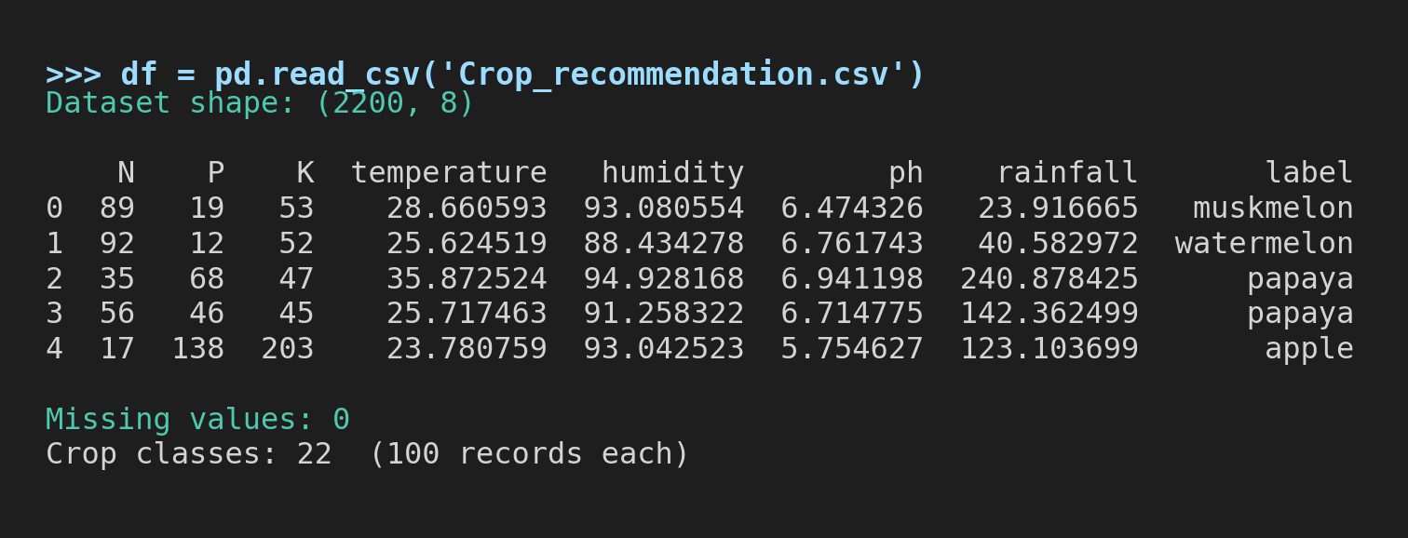
Real output — Crop_recommendation.csv loaded (2,200 rows × 8 columns, 22 balanced classes, 0 missing values)

Activity 1.2: Research and Select the ML Algorithm
- Reviewed the classification task: predicting one of 22 crop labels from 7 numeric features — a multi-class classification problem.
- Compared candidate algorithms: Logistic Regression, Decision Tree, and Random Forest.
- Selected Random Forest Classifier: for its strong out-of-the-box accuracy on tabular agricultural data, resistance to overfitting through ensembling, and built-in predict_proba() support needed for the confidence score and top-3 suggestion features.
- Configured with n_estimators=100 and random_state=42 for reproducible results.

Activity 1.3: Define the Application Architecture
- Frontend: Streamlit renders the input form and results directly in the browser — no separate HTML/CSS/JS needed.
- Backend logic: app.py validates input, loads model.pkl, and calls the model's predict() / predict_proba() methods.
- ML artifact: model.pkl is trained once offline (train_model.py) and reused across every prediction request.
- No database: the app is stateless — each prediction is computed fresh from the current form inputs.

Activity 1.4: Set Up the Development Environment
Create and activate a virtual environment, then install the project dependencies:
python -m venv venv
source venv/bin/activate # Windows: venv\Scripts\activate

pip install -r requirements.txt
requirements.txt:
pandas
numpy
scikit-learn
streamlit

Milestone 2: Model Training and Core Functionality Development
This milestone covers train_model.py — the script responsible for loading the dataset, training the Random Forest Classifier, evaluating it, and saving the reusable model.pkl artifact.

Activity 2.1: Load and Explore the Dataset
df = pd.read_csv("Crop_recommendation.csv")
print("Dataset shape:", df.shape)
print(df.head())

print("Missing values:\n", df.isnull().sum())
print("Crop classes:\n", df['label'].value_counts())
This confirms the dataset has no missing values and a clean, even class distribution before training begins.

Activity 2.2: Split Features/Target and Train-Test Sets
X = df[['N', 'P', 'K', 'temperature', 'humidity', 'ph', 'rainfall']]
y = df['label']

X_train, X_test, y_train, y_test = train_test_split(
X, y, test_size=0.2, random_state=42
)
An 80/20 train-test split with a fixed random_state keeps results reproducible across runs.

Activity 2.3: Train and Evaluate the Random Forest Classifier
model = RandomForestClassifier(n_estimators=100, random_state=42)
model.fit(X_train, y_train)

y_pred = model.predict(X_test)
accuracy = accuracy_score(y_test, y_pred)
print("Model Accuracy:", round(accuracy * 100, 2), "%")
print(classification_report(y_test, y_pred))
print(confusion_matrix(y_test, y_pred))
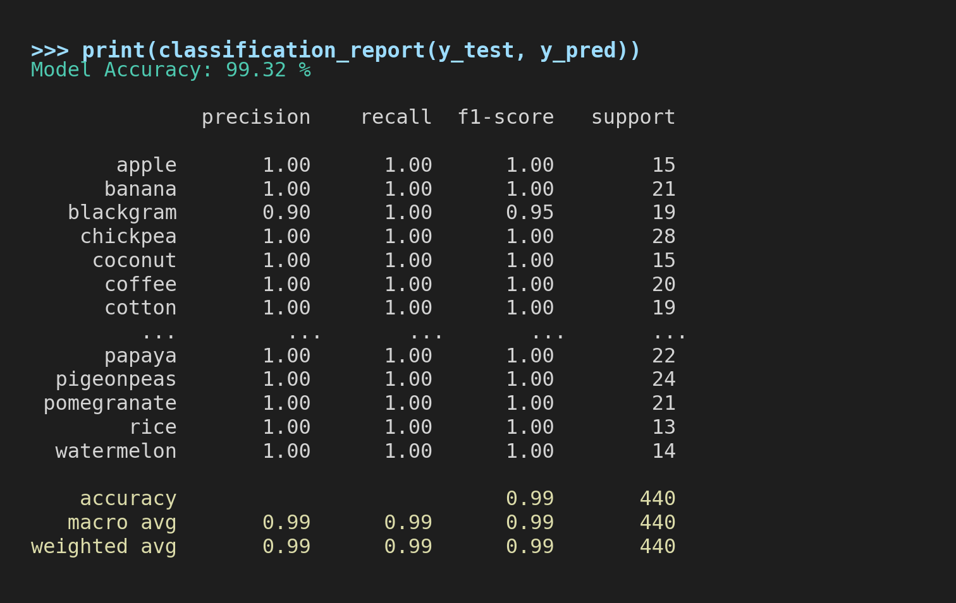
Real output — RandomForestClassifier(n_estimators=100, random_state=42) trained on this dataset: 99.32% test accuracy
On the held-out 20% test split (440 samples), the model reached 99.32% accuracy, with precision and recall at or near 1.00 for nearly every one of the 22 crop classes — confirming the dataset's clean class separation carries through to a strong, reliable classifier.

Activity 2.4: Persist the Trained Model
pickle.dump(model, open("model.pkl", "wb"))
print("Model saved as model.pkl")
Saving the model with pickle means app.py never needs to retrain — it simply loads model.pkl once at startup, making predictions near-instant.

Milestone 3: app.py Development
Milestone 3 covers the core application logic in app.py — the file that loads the trained model, defines the input form, and runs predictions when the user clicks the button.

Activity 3.1: Load the Model and Configure the Page
model = pickle.load(open("model.pkl", "rb"))

st.set_page_config(page_title="OptiCrop", page_icon="🌾")
st.title("🌾 OptiCrop: Smart Crop Recommendation System")
Model loading is wrapped in a try/except FileNotFoundError block, so the app fails gracefully with a clear message if model.pkl is missing rather than crashing.

Activity 3.2: Build the 7-Parameter Input Form
The form is split into two Streamlit columns for a compact, single-screen layout. Every field has a min_value/max_value range so Streamlit rejects out-of-range entries before prediction ever runs:
col1, col2 = st.columns(2)
with col1:
N = st.number_input("Nitrogen (N)", min_value=0.0, max_value=200.0, value=50.0)
P = st.number_input("Phosphorus (P)", min_value=0.0, max_value=200.0, value=50.0)
K = st.number_input("Potassium (K)", min_value=0.0, max_value=200.0, value=50.0)
temperature = st.number_input("Temperature (°C)", min_value=0.0, max_value=60.0, value=25.0)
with col2:
humidity = st.number_input("Humidity (%)", min_value=0.0, max_value=100.0, value=60.0)
ph = st.number_input("Soil pH", min_value=0.0, max_value=14.0, value=6.5)
rainfall = st.number_input("Rainfall (mm)", min_value=0.0, max_value=400.0, value=100.0)

Activity 3.3: Prediction Logic, Confidence Score, and Top-3 Suggestions
if st.button("Recommend Crop"):
input_data = pd.DataFrame([[N, P, K, temperature, humidity, ph, rainfall]],
columns=["N","P","K","temperature","humidity","ph","rainfall"])
prediction = model.predict(input_data)[0]
probabilities = model.predict_proba(input_data)[0]
confidence = round(max(probabilities) * 100, 2)

st.success(f"Recommended Crop: {prediction.upper()} ({confidence}%)")

top3_idx = np.argsort(probabilities)[-3:][::-1]
for idx in top3_idx:
st.write(f"- {model.classes_[idx]} ({round(probabilities[idx]*100,2)}%)")
predict_proba() returns a probability for every one of the 22 crop classes; sorting these gives both the confidence score for the top prediction and the two runner-up suggestions shown to the user.

Activity 3.4: Error Handling
- Input range validation → every st.number_input() field has a min_value/max_value bound (e.g. N and P are capped at 0–200, pH at 0–14). Streamlit blocks an out-of-range entry inline, with a red warning, before the value is ever accepted.
- Model loading failure (FileNotFoundError) → st.error() with a clear instruction to run train_model.py first, then st.stop().
- Prediction failure (any Exception) → caught and shown via st.error(), with an st.info() hint asking the user to re-check their inputs.
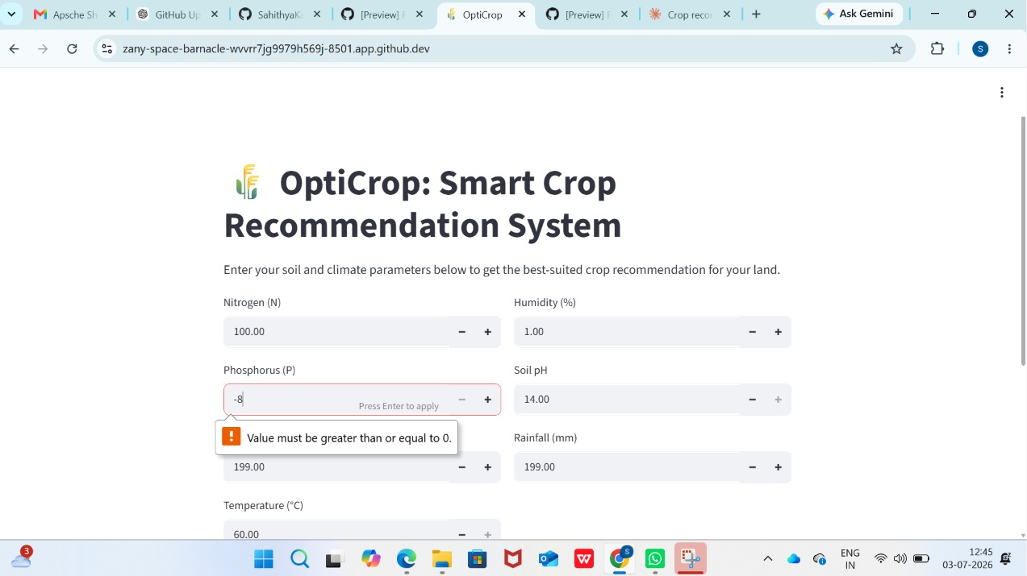
Range validation — Phosphorus rejected below its minimum (0)
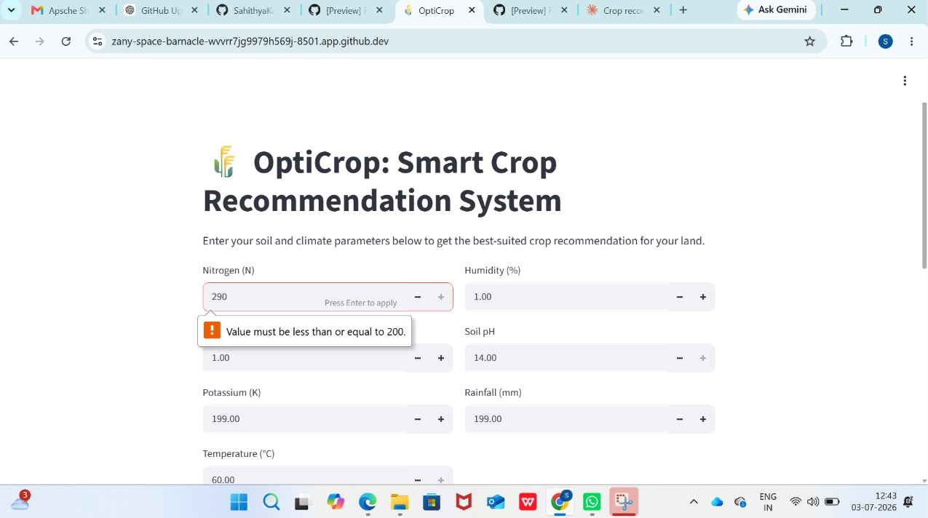
Range validation — Nitrogen rejected above its maximum (200)

Milestone 4: User Interface Design
Since OptiCrop is built entirely in Streamlit, there is no separate HTML/CSS/JS layer — UI design happens directly inside app.py through Streamlit's layout widgets. This milestone documents those UI/UX decisions.

Activity 4.1: Page Layout and Widgets
- Page title and browser tab icon set via st.set_page_config(page_title="OptiCrop", page_icon="🌾").
- A short st.write() instruction line orients first-time users before the form.
- The 7 inputs are split across two st.columns() so the whole form fits on one screen without scrolling.
- A horizontal st.markdown("---") divider and st.caption() footer close out the page with attribution.
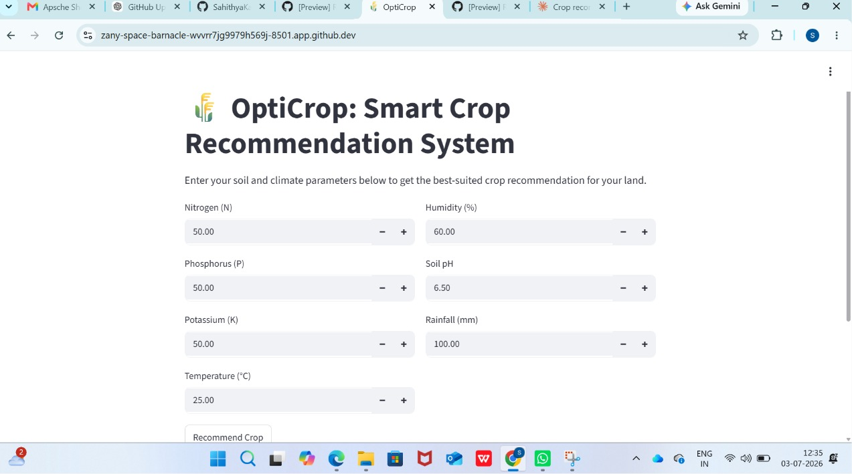
Live OptiCrop input form — default starting state (matches value= defaults in app.py)

Activity 4.2: Results Presentation
- st.success() renders the top recommendation in a green banner with the crop name and confidence percentage.
- The top-3 suggestions are listed underneath using st.write() bullet-style output.
- Errors are shown in a red st.error() banner so failed predictions are clearly distinguishable from successful ones.
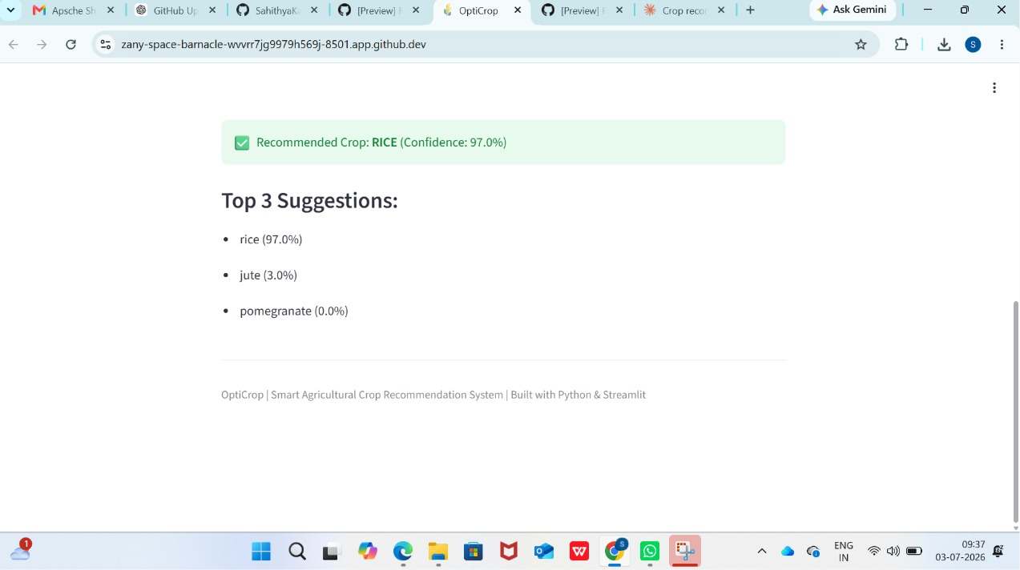
Live OptiCrop results — recommended crop with confidence % and top-3 suggestions

Milestone 5: Deployment
Milestone 5 covers testing OptiCrop locally, then deploying it publicly on Streamlit Community Cloud so it can be accessed from any browser without installation.

Activity 5.1: Local Testing
streamlit run app.py
Running streamlit run app.py starts a local server on port 8501. Development was carried out in a GitHub Codespaces environment, which forwards that port to a public preview URL (…app.github.dev) — functionally the same as testing on localhost, but accessible from any browser without a local Python install. Every input was tested with several value combinations to confirm predictions, confidence scores, the top-3 list, and the input-range validation all worked correctly before deployment.

App under test — GitHub Codespaces preview (zany-space-barnacle-....app.github.dev)

Activity 5.2: Push to GitHub
git init
git add .
git commit -m "OptiCrop: Smart Crop Recommendation System"
git branch -M main
git remote add origin https://github.com/your-username/OptiCrop.git
git push -u origin main
The .gitignore file excludes virtual-environment folders and other local artifacts so only the source files (app.py, train_model.py, model.pkl, requirements.txt, README.md) are pushed.

Activity 5.3: Deploy on Streamlit Community Cloud
- Sign in to share.streamlit.io with your GitHub account.
- Click "New app", select the OptiCrop repository and branch, and set the main file path to app.py.
- Click "Deploy" — Streamlit Cloud installs requirements.txt automatically and builds the app.
- Every future git push to the main branch automatically triggers a redeploy.
With the app fully tested in the Codespaces preview (Activity 5.1) and the source pushed to GitHub (Activity 5.2), this step hands the app off to Streamlit Community Cloud for permanent, public hosting — completing the path from local development to a live, shareable tool.

Exploring the Website's Web Pages

Home / Input Form Page

Home / Input Form Page — default view on first load
Description: The single-page interface of OptiCrop doubles as the landing page and the prediction tool. It opens with the 🌾 OptiCrop title and a one-line instruction, followed by the two-column input form covering Nitrogen, Phosphorus, Potassium, Temperature, Humidity, Soil pH, and Rainfall, and a "Recommend Crop" button. Every field opens pre-filled with a sensible default (N=P=K=50, temperature=25°C, humidity=60%, pH=6.5, rainfall=100mm) so the button can be pressed immediately without guessing values.

Results Section

Results Section — live app
Description: After clicking "Recommend Crop", a green success banner displays the top-recommended crop in uppercase along with its confidence percentage, followed by a "Top 3 Suggestions" list showing the two runner-up crops and their respective probabilities. For example, an input of N=90, P=42, K=43, temperature=23°C, humidity=82%, pH=6.5, and rainfall=220mm returns RICE at 97.0% confidence, with jute (3.0%) and pomegranate (0.0%) as backups.

Input Validation State
Description: Every field rejects out-of-range values inline before a prediction can run — see the two live examples (Phosphorus below its minimum, Nitrogen above its maximum) in Milestone 3, Activity 3.4.

Milestone 6: Conclusion

Activity 6.1: Review Against Project Goals
The original goal was a fast, no-guesswork way for a farmer to get a data-backed crop recommendation from basic soil and climate readings. OptiCrop meets that goal: it takes the same 7 values a soil-testing kit already provides (N, P, K, temperature, humidity, pH, rainfall) and returns a recommendation in under a second, with no signup, no installation, and no cost to the end user.

Activity 6.2: Documented Results
The working application, its input form, and its results view are captured in the "Exploring the Website's Web Pages" section above, alongside the local-run and Streamlit Community Cloud deployment screenshots in Milestone 5.

Activity 6.3: Future Enhancements
- Multi-language support so regional farmers can use OptiCrop in their own language.
- A more mobile-friendly layout for use directly in the field.
- Live weather-API integration to auto-fill temperature, humidity, and rainfall instead of manual entry.
- Follow-on fertilizer or irrigation recommendations alongside the crop suggestion.

Summary
OptiCrop is a lightweight, ML-powered Streamlit application that replaces guesswork-based crop selection with a fast, data-driven recommendation. Built around a Random Forest Classifier trained on the Kaggle Crop Recommendation dataset, it takes seven soil and climate parameters and instantly returns the best-suited crop, a confidence score, and two backup suggestions — all through a single-page interface that needs no installation once deployed. Through this Development Phase, the team implemented the full pipeline from dataset preparation and model training (train_model.py) to the user-facing prediction app (app.py), and deployed it publicly via Streamlit Community Cloud.

